Charity No: SC009963 March 2024

NAIRN UNITED REFORMED
CHURCH CHRONICLE

“I have been crucified with Christ and I no longer live, but Christ lives in me. The life I live in the body, I live by faith in the Son of God, who loved me and gave
himself for me. I do not set aside the grace of God, for if righteousness could be gained through the law, Christ died for nothing!”

Galatians 2: 20 & 21

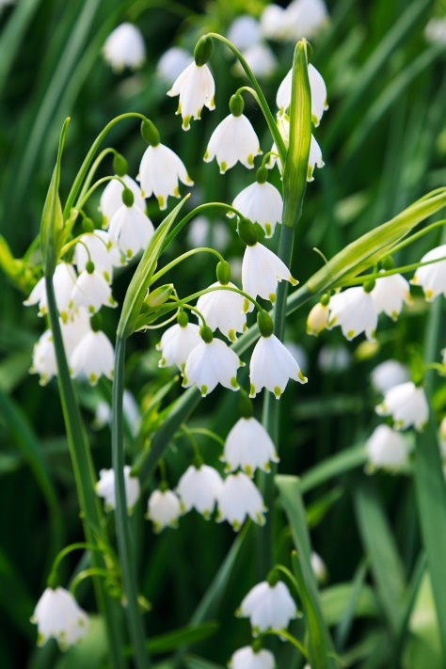

Hello Everyone!

I think my favourite spring flower must be the Snowdrop!
I always think it is so delicate to see the Snowdrops come out first in Springtime. They are probably the most delicate of all flowers yet they must also be so hardy to push themselves up through the frost hardened earth. It just goes to show that small delicate things are often not what they seem!!!
Snowdrops remind me of Christ and His crucifixion. He also was Just a man while on this earth yet he was so brave to die for all our sins.
Happy Easter to you all!
Virginia Innes (Babity)

………………………………………..From our Minister
Dear friends

I thank God daily, not just for the beauty we see each day that surrounds us, but also for each other, those we share our lives with. I say this because I have just come in from a lovely walk along the beach friends; it has been a wonderful afternoon, with the sun shining in a fading winter Sky. On the way we saw emerging displays of spring flowers, snowdrops, crocuses and budding daffodils, standing out against the soil and grass. There was a real lightness in the steps of those people I passed, all enjoying the sunshine and fresh air. There was a sense of Spring in the air and subliminally maybe a sense of new beginnings. Our circumstances are changing daily and hopefully we can look forward to warmer and longer hope filled days.

This got me thinking- Easter is just around the corner and the season of Lent is coming to its end, March has been a busy month, what with Lent, Mothering Sunday, the clocks going forward an hour, and all of us looking forward to Holy Week and Easter. It is with this in mind that we have much to be grateful for in our church.

Like many of you I am just glad that we can gather as a worshipping community each Sunday. The work of the congregation continues. The pastoral group meets to arrange support for older and frailer people in the congregation, the building is open to diverse groups and is used ecumenically and for people of faith and none through the warm space. Debbie Smith does a wonderful work with people struggling with addictions and mental health problems. The Rev Johnathan Turner and our Baptist friends host a weekly mindfulness and wellbeing day in the building, Mikey’s Line meets at the church to support people needing a listening ear and we have a couple of new projects in the pipeline to help move forward the idea of a church open to all and especially those who struggle in life. These events are all part of a bigger plan that I believe the Lord is leading us into this year. The church doors at Nairn URC are open to allow people into the building irrespective of their connection to us and it is my prayer that we will see more doorways open into the church for those in our community who do not yet know the redemptive love of Jesus. Because that, dear friends, is why we are here: to share that same love with our neighbours, so that they may find themselves caught up in the great story of God. So may you find a way to become a “door” for someone else this Easter so that Nairn URC becomes a true place of welcome in the name of the risen Christ
We can be so grateful and joy-filled to gather as an open and inclusive community of faith in the Lord’s resurrection, especially when many people do not welcome others because of who they are, where they are from, who they love or what they believe. The empty cross and message of Easter reminds us that all people are offered a love and a hope that binds us up to face the challenges that arise in life. Christ is with us, indeed!

with every blessing and a Happy Easter

Rev Steven

<><><><><><><><><><><><><><><><><><><><><><><><>

Below is a note of the Holy Week Services being held:

Monday 25th March St Columba’s Episcopal Church
Tuesday 26th Nairn United Reformed Church
Wednesday 27th Nairn United Reformed Church
Thursday 28th Nairn Free Church
Friday 29th Nairn Free Church

THE CHRISTMAS MEALS ALL READY TO GO TO THOSE WHO ARE ON THEIR OWN DURING THE FESTIVE PERIOD. THANKS TO ALL THOSE INVOLVED IN THE PREPARATION AND DELIVERY OF THE MEALS. Many thanks to Peter Ranscombe for the photos.

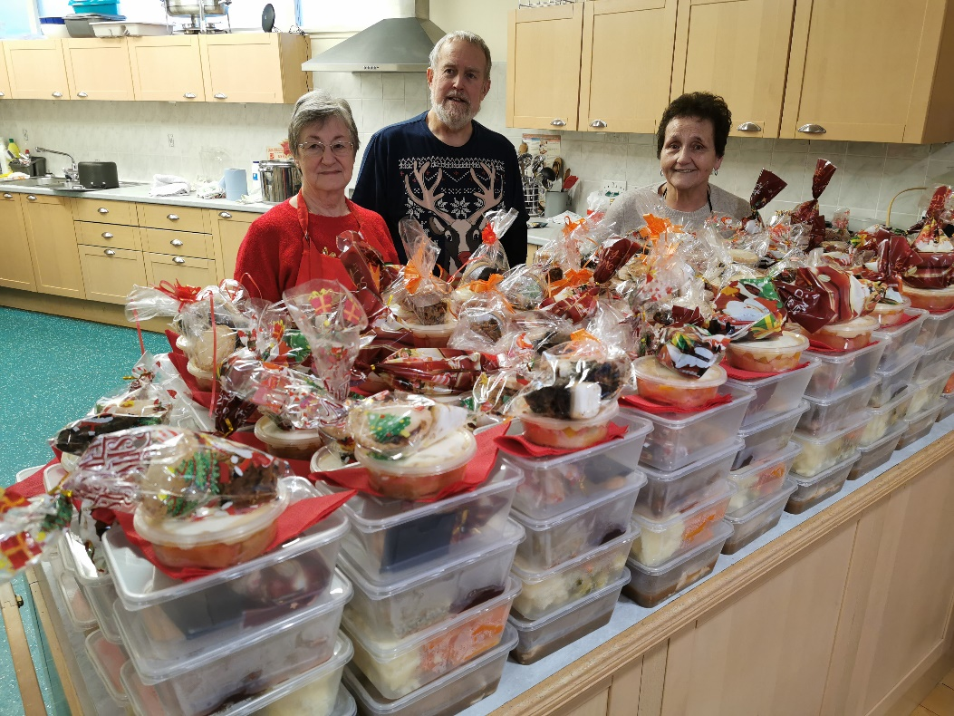

Many thanks to all those involved in the hard work!!

I cannot change the way I am
I need not even try
We each are different and unique
No need to question why
Should I appear peculiar
Then there’s nothing I can do
Please just accept me as I am
As I’ve accepted you!

Inserted by Florence Knowles

I love a house that’s lived in
With clutter here and there
A magazine left open
A jacket on a chair
A smell of something cooking
A special recipe!
An over eager offer of hospitality!
I love a house that’s “lived in”
It seems to stand apart
For in it is a woman
Who has a loving heart!

Inserted by Babity

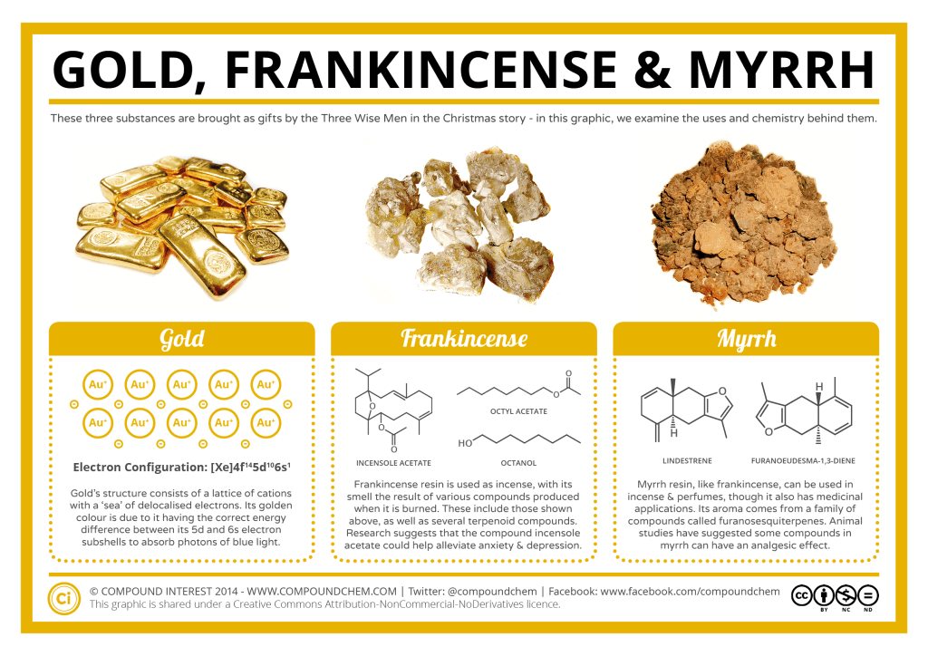

'How many have wondered why myrrh was one of the three items that the Magi chose to offer the infant Christ? I certainly have as I have been unsure what exactly were the properties to make it so becoming.

On investigation one finds that it is a natural gum resin or juice from the balsa tree. As a powerful medicament it was highly valued. The best, originated from two small plantations in Jericho in Jordan with the larger one being only twenty acres. It was known as Balm of Gilead. Almost certainly this will have been the myrrh that accompanied the gifts of gold and frankincense. No other myrrh could rival it.

So well esteemed was the Queen of Sheba presented this as her foremost gift to Israel’s King Solomon. After all, he was the wealthiest man of his time and a legend still. It must have been quite a problem to know what to present him on her state visit! But Balm of Gilead it was.

This poem forgoing rhyme endeavours to encapsulate the situation.
Even today the expression' Balm of Gilead ' signifies a universal cure in figurative speech. It also refers to Christ as the ultimate saviour for our ills.'

Inserted by Ian Nalder

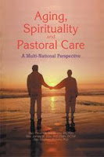

The Pastoral group continue to be very supportive to many in the community and two of the care homes. We are very fortunate to have such loyal Church members who are willing to give of their time to visit the lonely and ill. So, to them I think we owe our grateful thanks. I am aware that there are members of the Church who also do visits and are not part of the Pastoral group so on behalf of the Church we are very thankful to them.

Christmas 2023, Our Christmas meals were very successful again and we delivered 54 meals. Some wanted to contribute towards providing the meal and Stephen and I were very grateful to them.
But please know that the meals are free to those who receive them and we do not expect any contribution.

In February we held the 15th Inter Church Quiz. I started this in 2007 and it has always been well attended. We did have a break of 3 years due to Covid but last year we started again. This year we had 15 teams, but due to the school half term the Baptist Church were unable to enter a team this year, it’s the first year they have missed.
I would like to thank Jean Innes my “number cruncher” who has been with me from the beginning for making sure the numbers are recorded correctly. Also, thanks to Alison Smith, Val Thomson and Mairi Ryan for serving the refreshments and clearing away. Everything works so much better with good team work.
I must not forget to say that the URC won the trophy. That was our third win in 15 years. All the table money goes to the winning team who in turn must donate it to a charity of their choice. It was donated to Mickey’s line who help people with mental health issues.

Inserted by Angela Quinn

<><><><><><><><><><><><><><><><><><><><><><><><><><><><><><><><><><><><><><>

INTER CHURCH QUIZ
WINNING TEAM!!

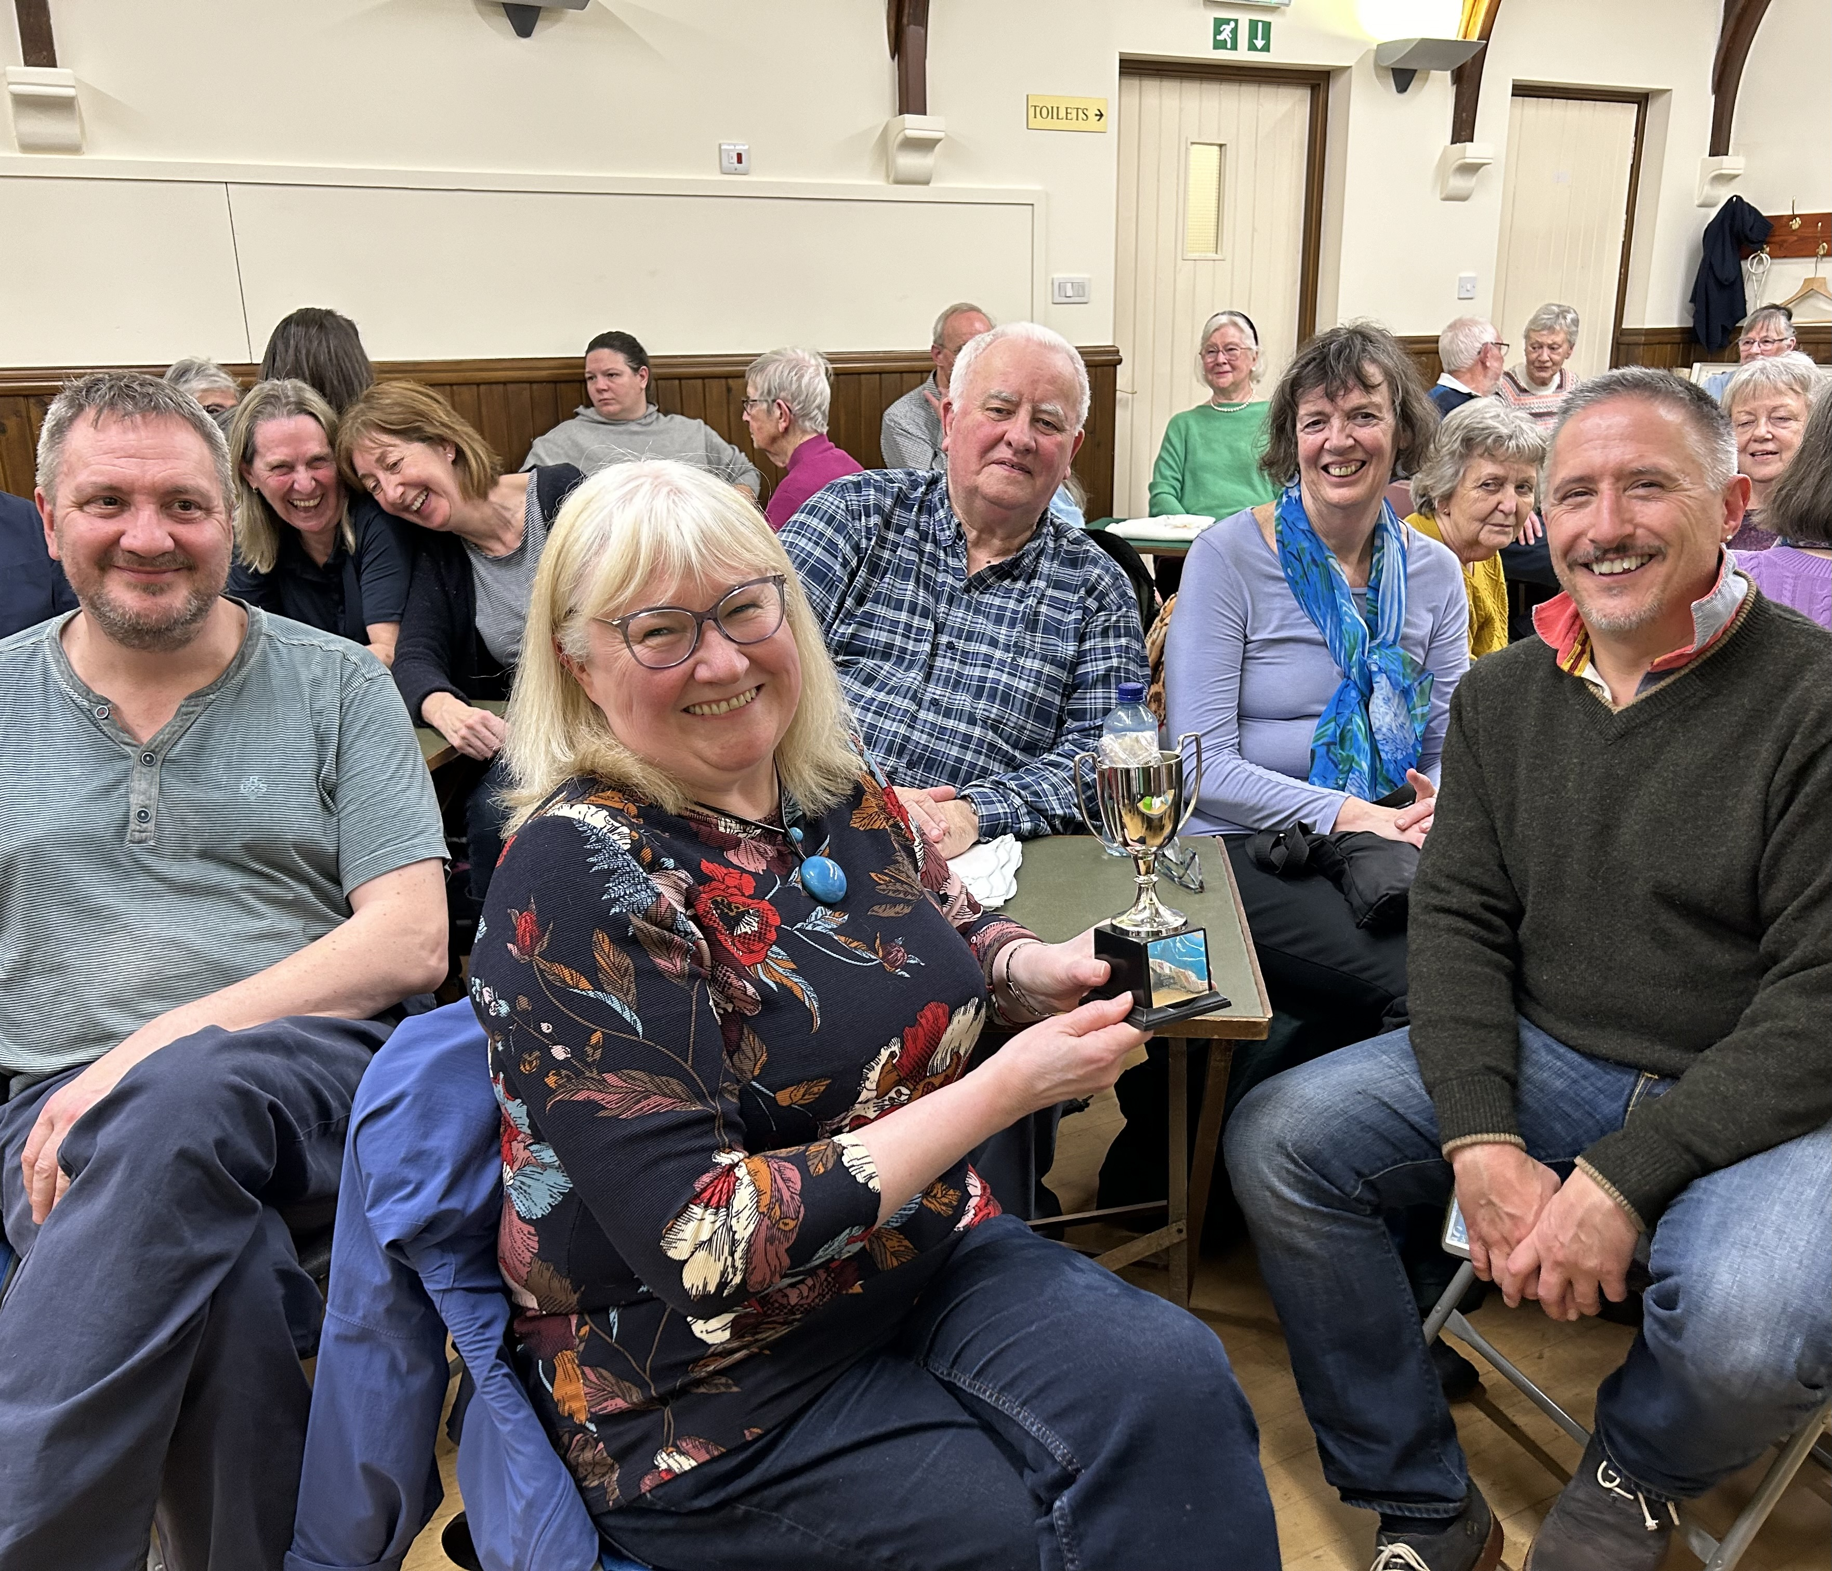

WELL DONE!!

- Signs You’re Doing Well in Life
- You have a roof above you.
- You ate today.
- You have a loving heart.
- You wish good upon others.
- You have clean water.
- Someone cares for you.
- You forgive others.
- You have clothes to wear.
- You smile.
- You’re breathing

LET’S ALL THANK GOD FOR ALL OUR BLESSINGS!

Inserted by Angela Quinn

Stamp Appeal
600g of stamps (and that is quite a lot of stamps!) have been forwarded to support a community-based agroforestry project to establish tree nurseries across Malawi, Zambia and Zimbabwe.
The project, ‘Firmly Planted’ is spearheaded by the Church of Central Arica Presbyterian (CCAP), a partner church of the Church of Scotland. The initiative will resource individual groups to respond to the various challenges affecting Malawi today.
Agroforestry presents an opportunity to address challenges of food insecurity, deforestation, climate change and youth unemployment. Tree nurseries create employment opportunities, fruit trees improve nutrition and wider tree planting helps mitigate the impact of the climate crisis, in turn improving agricultural productivity.
The CCAP project will provide community-based training ensuring woodlands are well maintained to have the greatest chance to thrive and aims to establish self-sustaining tree nurseries to nurture and protect the environment and protect livelihoods for households and communities.
Donating your used stamps is an easy, zero cost way to support this worthwhile project so why not team up with friends, family or colleagues and collect together. Simply cut the postage stamp from the envelope, taking care not to damage the stamp and making sure to leave approximately 1cm of envelope bordering the stamp.
Please keep saving your stamps and deposit them in the box in the front hall. Your support is much appreciated.

Jean Innes

Gift Aid is a valuable source of income for the church. If you pay UK Income Tax or Capital Gains Tax please consider completing a Gift Aid declaration to boost your donations by 25p of Gift Aid for every £1 you donate. Please speak to either Jean Innes or Irene Macdonald for more information.
If you have given the church a Gift Aid declaration in the past but are no longer paying tax, please remember to let either Jean or Irene know.

<><><><><><><><><><><><><><><><><><><><><><><><><><><><><>

CHILDREN’S CORNER

Finance report for year to 31 December 2023

Firstly, as I take on the role of Church Treasurer, I would like to acknowledge the diligent work that Derek Innes has done during his 3 year term as Treasurer, handing over the accounts to me in excellent order. I am grateful to Derek for all the help he has given me as I take on this new role.
Secondly, I would like to thank Maureen and her team, Irene, Pat and Dianne, for their support, and also Jean Innes for all her work on Gift Aid.
The income to the General Fund, for the year 2023, was £84,631 and the expenditure £75,881. Additionally, the Fabric Fund had an expenditure of £13,945.
The Benevolent fund has been generously supported which has enabled £11,500 to be directed to those in need in the community.
The giving has increased by nearly 30% from the previous year, thanks to increased Sunday attendance and individuals increasing their regular giving, for which we thank them.
In 2023 we received £11,132 of Gift Aid, being tax that people had paid, and which is returned to the church by the Inland Revenue. To Gift Aid your giving is very simple and is an option for anyone who pays any income tax. On the amount you give, the church can claim from the Inland Revenue an additional 25%. You can cancel Gift Aid at any time. If you would like to find out more, please speak to Jean Innes or myself, or any of the Elders.

Martin Harker
Church Treasurer

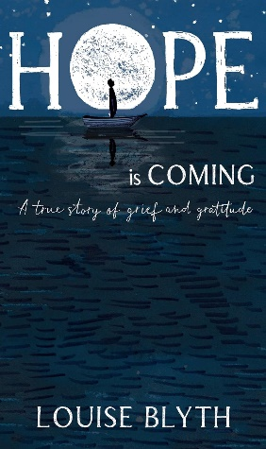
BOOK REVIEW

Hope is Coming
A true story of grief and gratitude
by Louise Blyth

How can you lose the love of your life, but gain the greatest love you can ever know?

In this gripping memoir, Louise Blyth charts the love story she shared with her husband and shares how it prematurely toppled into grief, pain and enlightenment.
Hope Is Coming documents what happened when thirty-three-year-old George, a stoical and dynamic father of two, was diagnosed with advanced cancer. Told through letters, love notes and text messages, this true-story shares beautiful insight into one of life's biggest milestones.
In her despair, Louise screams into the night sky “God, if you are real, if you are as good as everyone says you are, show me you’re real”. Thus unfolds the story of God gently revealing his loving care for her.
It tenderly provokes a deeper look inside our hearts and shines a light on some of life's biggest questions. The couple's story highlights the strength and fortitude of the human spirit, whilst also teaching that peace and connection with God can emerge from sadness. This book will speak to all of those who have loved, lost and search for the meaning of life in death.

Martin Harker

URC WALKING GROUP

The Church still has a walking group which meets at the church every Wednesday morning at 10 am sharp. We either walk from the church on various routes along the beach, up the river or occasionally we take a car and travel a short distance to other areas like Brodie, Ardersier and Culbin. The walk usually lasts an hour to one and half hours and we always finish at a cafe for tea, coffee and a scone or even a bacon roll!
The group is not exclusive to our church members and we would be very happy to welcome some new participants. All that’s needed are some waterproofs (hopefully on not too many walks) and some sensible shoes, trainers etc
Come and join us and enjoy our surroundings.

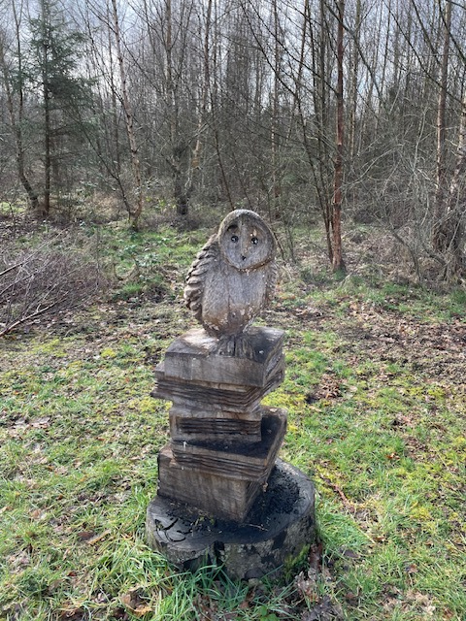

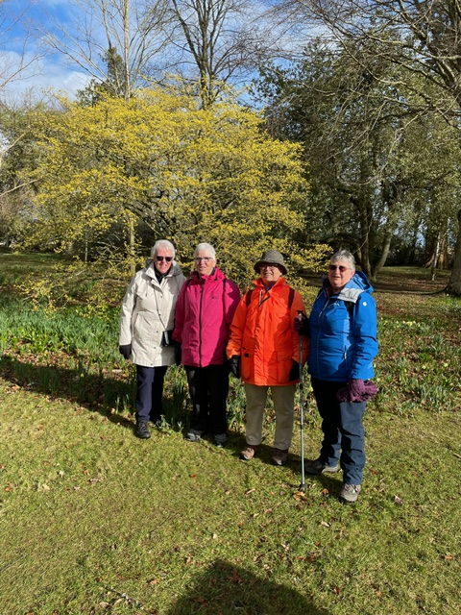

Inserted by Val Thomson

GARDENING NOTES – SPRING 2024

Rapidly lengthening days and the thought of warmer weather will encourage us to get out into the garden. Another season beckons and already we are handsomely rewarded for our efforts last autumn by the snowdrops, crocuses and daffodils already in flower. We also had a tulip filled ceramic pot which last year escaped the attention of Brock the Badger. Not this year however! We slept in ignorance while only feet away he indulged in his favourite delicacy!

'The Gardener's Hymn' portrays an accurate picture of the challenges we can all face along the way but true garden lovers rise above them and gain immense satisfaction from planning, sowing, weeding, watering and eventually enjoying the results!

The Gardener's Hymn

All things bright and beautiful
All creatures great and small
All things wise and wonderful
The Lord God made them all.

But what we never mention
Though gardeners know it's true
Is when He made the goodies
He made the baddies too.

All things spray and swatable
Disasters great and small
All things paraquatable
The Lord God made them all.

The greenfly on the roses
The maggots on the peas
Manure that fills our noses
He also made all of these.

The fungus on the goosegogs
The clubroot on the greens
The slugs that eat the lettuce
And chew the aubergines
The midges and mosquitoes
The nettles and the weeds
The pigeons on the greenstuff
The sparrows on the seeds,

The fly that gets the carrots
The wasp that eats the plums
How black the gardener's outlook
Though green may be his thumbs.

But still we gardeners labour
Midst vegetables and flowers
And pray what's hit our neighbours
Will somehow bypass ours!

Supplied by Jean Innes. (Author unknown)

I think this hymn has some age as paraquat is a definite, banned 'no-no'. A vinegar and salt spray is commonly promoted as an effective weed killer as long as plants are protected but apparently boiling water is kinder to the soil.

In conclusion:- Bees can become very dehydrated. To help, grated apple in water helps to revive them.

Garden well,
Roy and Chris.

Rev. Steven Manders
12 Newton Gate
NAIRN
IV12 4TS
01667 454198 or 07808 476733
stevenmmanders@gmail.com

Church Secretary
Stephen Ranscombe
01667 452239
stephen.ranscombe@hotmail.com

Treasurer
Martin Harker
01309 641006
nairnurc123@gmail.com

Hall Hire
Pat MacMillan
01667 455692

pat.broomcottage@mypostoffice.co.uk

Pastoral Group
Angela Quinn
01667452995
07920195142
quinnie@btopenworld.com

